ASSIGNMENT NO. 4-Implementation of ReactJs
Name: Jatin Vishwakarma
Branch: Computer Science & Engineering (Un-Aided)
Batch: S-8
PRN: 255209004
Problem Statement 1. To-Do List
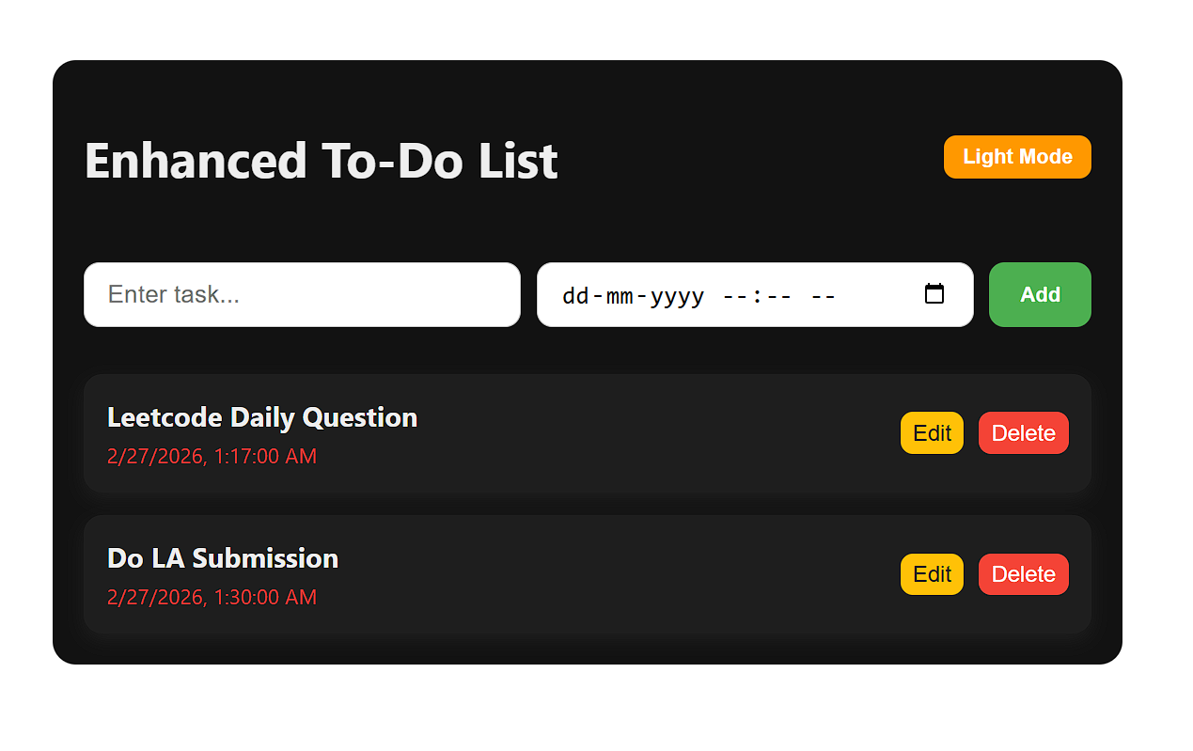
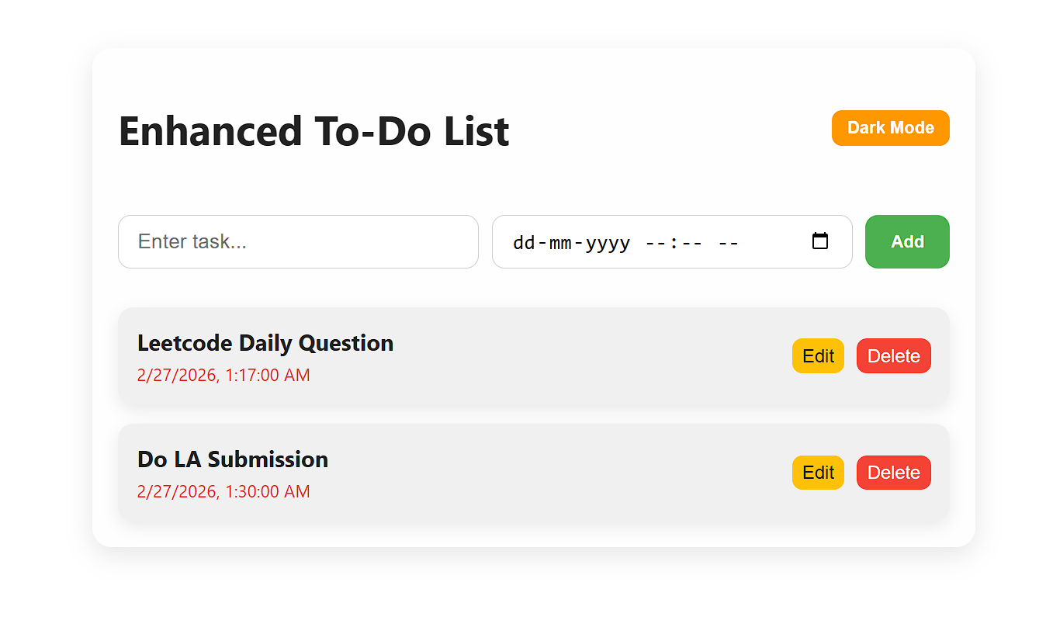
OUTPUT: (Light & Dark Mode)

Problem Statement 2. Weather Application.
OUTPUT:
